Create Benchmark Strategy Backtest
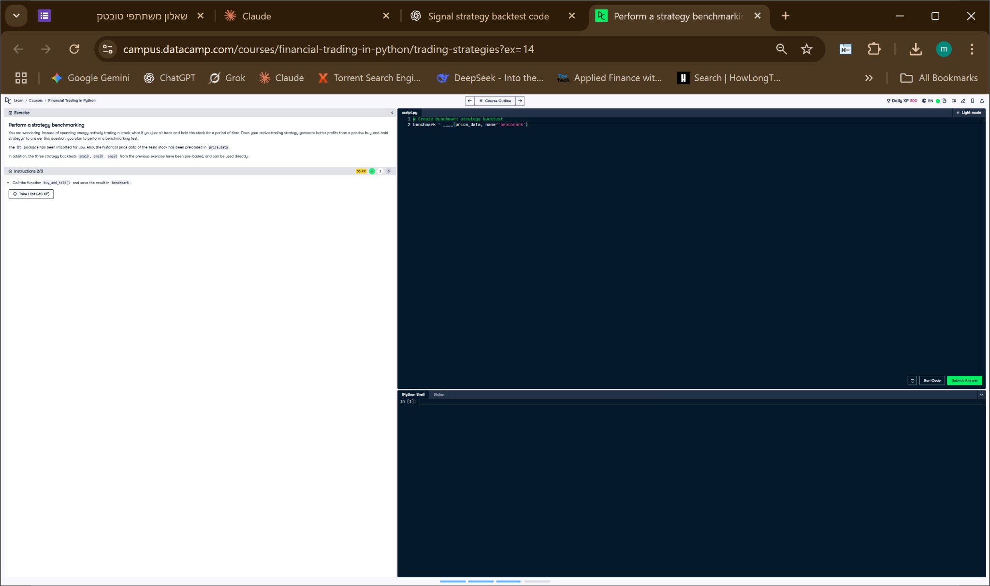

Python Code
# Create benchmark strategy backtest
benchmark = buy_and_hold(price_data, name='benchmark')

Explanation
This code calls the previously defined buy_and_hold() function with the Tesla stock data. It creates a passive investing strategy named 'benchmark', which will be used to compare against other strategies. The result is stored in the variable 'benchmark' as a backtest object.

